Character Arc Handout
Place what happens to the character in your story on the following diagram….
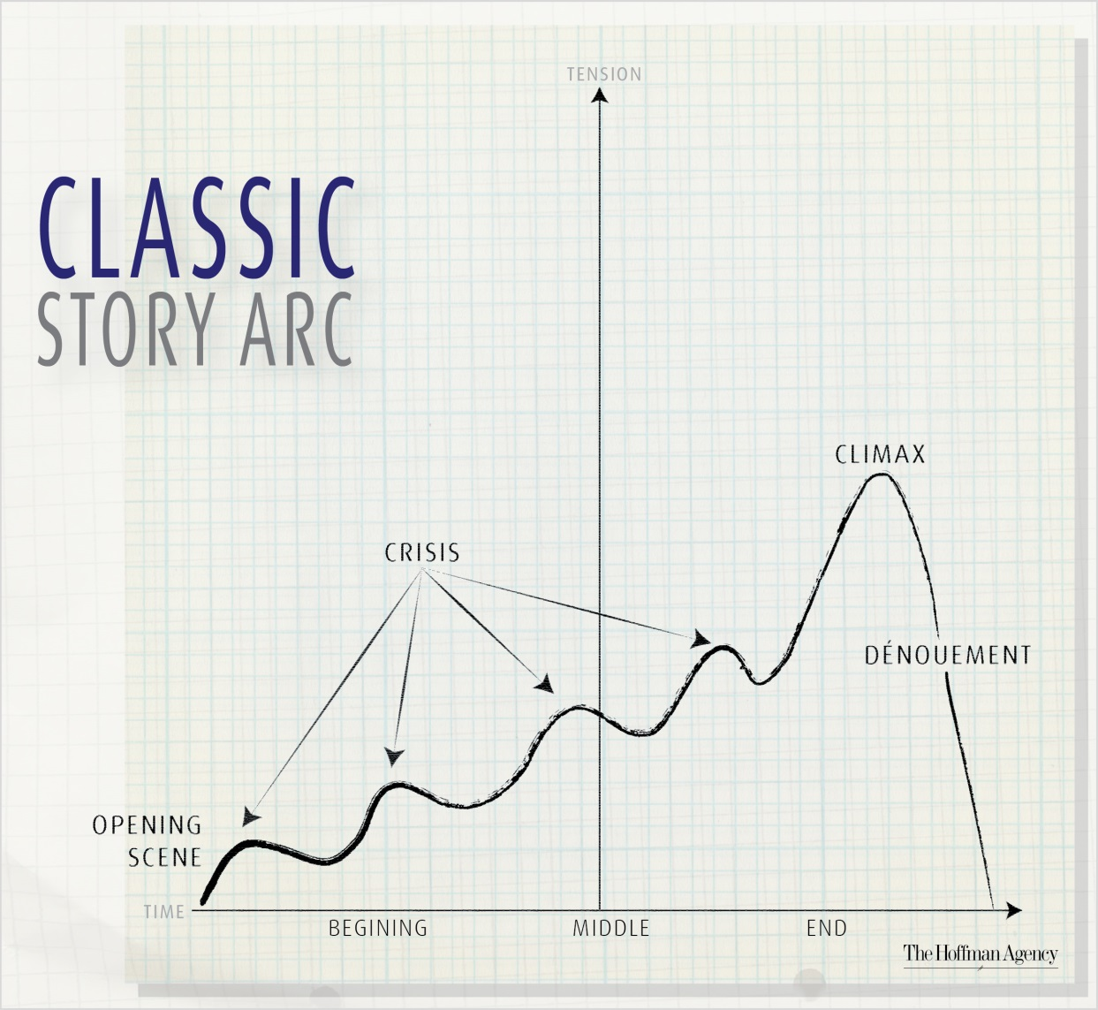
OR
Complete the following sentence…
[Describe protagonist],
who is currently [describe normality]
experiences [describe disturbance]
responds by [describe plan in response to disturbance]
but everything changes when [describe surprise that turns into obstacle which drives the story] which causes [describe increasing complications]
which are resolved ultimately by [describe climax]
after which the story ends with [describe resolution].

